* Setup

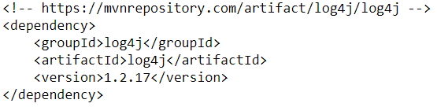

* Levels

|  |  |
| --- | --- |
| **Levels** | **Description** |
| OFF | turn off logging. |
| WARNING | This is a message level that indicates a problem. |
| SEVERE | This is a message level that indicates a failure. |
| INFO | This level is used for informational messages. |
| CONFIG | This level is used for static configuration messages. |

* TODO
* **Reference**

<https://www.javatpoint.com/hibernate-logging-by-log4j-using-properties-file>

<https://www.tutorialspoint.com/log4j/log4j_sample_program.htm>